**DAILY ONLINE ACTIVITIES SUMMARY**

|  |  |  |  |  |  |  |  |  |
| --- | --- | --- | --- | --- | --- | --- | --- | --- |
| **Date:** | **23-05-2020** | | | | | **Name:** | **Dhanush Shetty** | |
| **Sem & Sec** | **8 A** | | | | | **USN:** | **4AL16CS032** | |
| **Online Test Summary** | | | | | | | | |
| **Subject** | | **-** | | | | | | |
| **Max. Marks** | | **-** | | **Score** | | | **-** | |
| **Certification Course Summary** | | | | | | | | |
| **Course** | **Introduction to EC2 Auto Scaling.** | | | | | | | |
| **Certificate Provider** | | | **AWS** | | **Duration** | | | **10 mins** |
| **Coding Challenges** | | | | | | | | |
| **Problem Statement:**   1. **Write a C Program to Display first N Triangular Numbers** | | | | | | | | |
| **Status: Solved** | | | | | | | | |
| **Uploaded the report in Github** | | | | | **Yes** | | | |
| **If yes Repository name** | | | | | **Dhanushshett/online_c_coding_repositorys** | | | |
| **Uploaded the report in slack** | | | | | **Yes** | | | |

Certification Course Details: (Attach the snapshot and briefly write the report for the same)

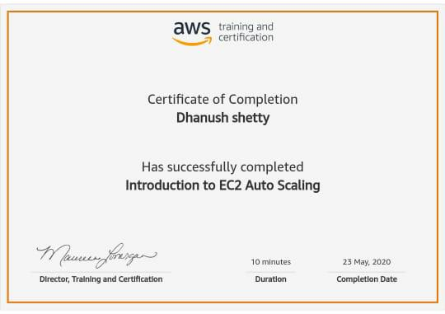

Coding Challenges Details: (Attach the snapshot and briefly write the report for the same)

**PROGRAM 1 .**

**// Write a C Program to Display first N Triangular Numbers**

#include <stdio.h>  
void triangular_series(int n)  
{

for (int i = 1; i <= n; i++)

printf(" %d ", i*(i+1)/2);

}

int main()  
{

int n ;

printf("Enter value for n");

scanf("%d",&n);

triangular_series(n);

return 0;

}